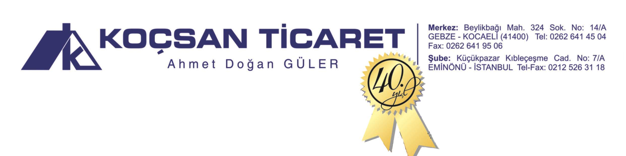
KOÇSAN TİCARET - AHMET DOĞAN GÜLER

DOĞAL ÇAM KATRANI (NATURAL PINE CATEGORY) ANALİZ RAPORU (ANALYSIS REPORT)
20.01.2017

BOILING POINT : 110 degC
GRAVITY : 1.02-1.08
FLASH POINT : 95 degC
VISCOSITY : 200-210 CP(50degC)
ASH : 0,3 %(weight)
ASID NO : 79
SHELF LIFE : 2 YIL

